# By:

Project Report 3

Market segmentation on using chatbots and LLMs in commercial sector.

# Vedant Poal [Implementation]

* Vishwas Dubey [Market Segmentation]

# Yuktha T D [Business Modeling] Abstract:

Market segmentation is a crucial strategy for businesses and educational institutions alike to effectively target and engage with their audience. Leveraging Language Models (LLMs) and Chatbots can enhance segmentation processes by providing personalized interactions and insights. This report explores the application of LLMs and Chatbots in

market segmentation within both commercial and education sectors, utilizing a dataset from a university.

# Introduction:

Market segmentation involves dividing a heterogeneous market into smaller, more manageable segments based on certain characteristics such as demographics, behaviour, or preferences. This approach allows organizations to tailor their marketing efforts, products, and services to better meet the needs of specific groups within their target audience.

In recent years, advancements in natural language processing (NLP) have led to the development of powerful LLMs, such as OpenAI's GPT, and sophisticated Chatbots

capable of engaging in natural conversations with users. Integrating these technologies into market segmentation processes can revolutionize how businesses and educational institutions understand and interact with their customers or students.

# Methodology:

For this project, we obtained a dataset from a university comprising information about students, including demographics, academic performance, extracurricular activities, and preferences. We utilized this dataset to demonstrate the application of LLMs and Chatbots in market segmentation within the education sector.

Data Collection and Preprocessing: We collected data from the university's student records and conducted preprocessing tasks such as cleaning, normalization, and feature engineering to prepare the dataset for analysis.

LLMs for Text Analysis: Using LLMs, we analysed textual data from student feedback, course evaluations, and social media interactions to extract insights regarding student preferences, interests, and sentiments.

Chatbots for Interaction and Feedback: We developed a Chatbot interface to engage with students, collect feedback on various aspects of their academic experience, and provide personalized recommendations for courses, extracurricular activities, and

support services.

Segmentation Analysis: Leveraging the insights obtained from LLMs and Chatbot

interactions, we performed segmentation analysis to identify distinct student segments based on factors such as academic performance, interests, engagement level, and

support needs.

# Results and Findings:

The integration of LLMs and Chatbots yielded several notable findings and outcomes:

Personalized Recommendations: The Chatbot was successful in providing personalized recommendations for courses, study resources, and campus activities based on

individual student preferences and feedback.

Segment Identification: Through segmentation analysis, we identified several distinct student segments, including high achievers, social butterflies, struggling students, and career-focused individuals, each requiring tailored approaches for engagement and

support.

Improved Engagement: The use of Chatbots for communication and feedback

collection resulted in increased student engagement and satisfaction, as it provided a convenient and interactive platform for expressing opinions and accessing relevant

information.

Targeted Marketing: Businesses and educational institutions can utilize the insights derived from segmentation analysis to develop targeted marketing campaigns, personalized communication strategies, and customized offerings to better meet the needs of different customer or student segments.

Conclusion:

Market segmentation using LLMs and Chatbots presents a promising approach for enhancing customer and student engagement, improving service delivery, and

optimizing marketing strategies in both commercial and education sectors. By leveraging the power of natural language processing and conversational AI,

organizations can gain deeper insights into customer/student preferences and behaviours, leading to more effective segmentation and personalized experiences.

* Approach 1:

Utilizing Google's Dialogflow API, we'll integrate a Chatbot into the university's website. This Chatbot will assist with market segmentation, offering

personalized recommendations and gathering feedback. It will also enhance website navigation, providing a seamless user experience for students and visitors.

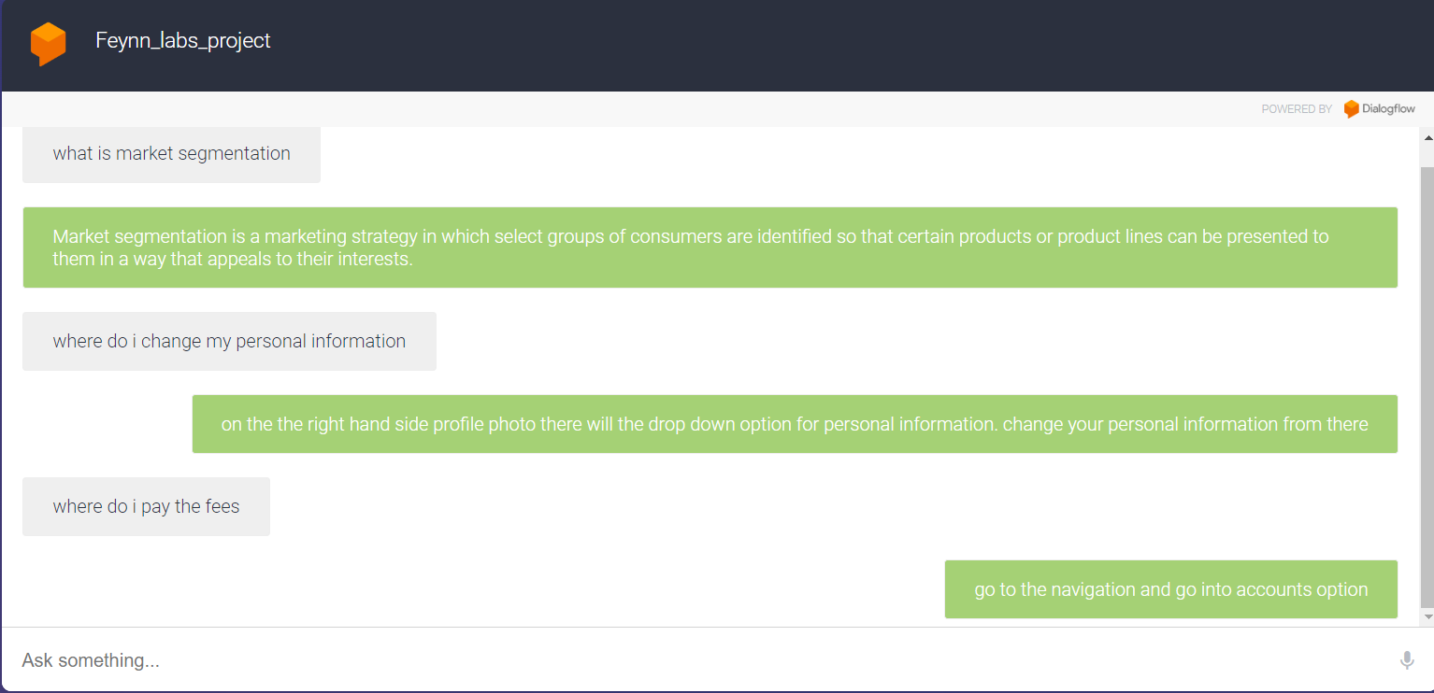

* Approach 2:

In approach 2, we leverage GPT-3 as our foundational Language Model (LLM), customizing parameters to create an interactive bot. This advanced bot

combines the functionalities of a traditional chatbot with the capabilities of an LLM, enabling natural language understanding and generation. It engages users in dynamic conversations, offering personalized responses, recommendations, and insights. Beyond typical chatbot interactions, it can comprehend complex queries and generate contextually relevant responses. This innovative solution enhances user engagement and satisfaction, providing a seamless blend of

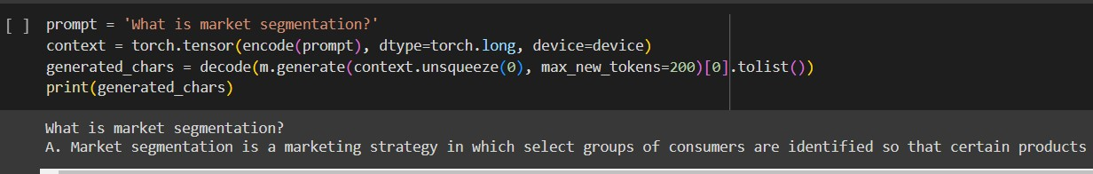conversational AI and sophisticated language processing tailored to the unique needs of our market segmentation project.

* Approach 3:

In our approach, we utilize Flax T5 as the foundation for our model, customizing parameters to tailor its functionality. This adaptation allows us to create an

interactive bot with enhanced capabilities beyond traditional chatbots. By

leveraging Flax T5's advanced language processing abilities, our bot can engage users in dynamic conversations, offering personalized responses and insights. Its flexible architecture enables us to incorporate specific parameters to suit the requirements of our market segmentation project. This innovative solution

enhances user interaction and satisfaction, providing a seamless integration of sophisticated language processing and conversational AI to drive effective segmentation strategies.

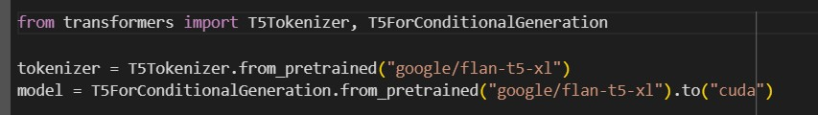

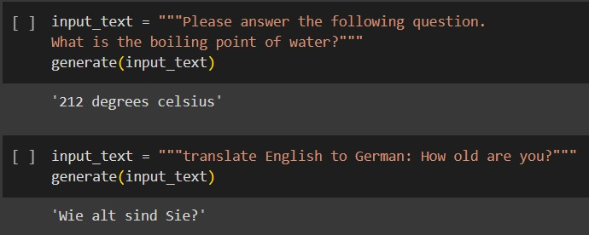

Future Directions:

Moving forward, further research and development efforts can focus on refining LLMs and Chatbots to better understand nuanced language patterns, emotions, and context, thereby enhancing the accuracy and effectiveness of segmentation analysis.

Additionally, exploring the integration of other emerging technologies such as machine learning and predictive analytics could further enrich the segmentation process and

drive better decision-making in marketing and education management.

Market Segmentation :

The market segmentation leverages a university dataset to identify distinct customer groups. The data incorporates various user characteristics, including willingness to use chatbots, age, and gender. Additionally, it considers company factors such as chatbot ownership and the historical growth of trainable parameters within these chatbots.